From The Izard County Historian. Volume 1, January, 1970, No. 1, pages 3 – 9.

“The Trimble Family — Izard County Pioneers”

“The old Trimble house, the Trimble Campground Church and the Trimble Cemetery are landmarks at Dolph but until recently little was known about the family or their origin. The last member of the family carrying the Trimble name left Izard county some time between 1865 and 1868. W. M. Gentry in his history of North Izard County describes the move.

‘Uz Filey with W.L. Avlor, Steve Wayland and John Newton Trimble moved from Izard County and bought White River bottom land farms. Avlor, Wayland and Finley’s farms were just below Bull Shoals Dam and Trimble’s farm about one mile above.’ This general area later became know as Trimble Flats and is now Lakeview. W.M. Gentry taught school at Trimble Flats in 1897.

John Newton Trimble was a son of James Finis Trimble who arrived in Arkansas from Kentucky in 1811 at the age of 21. He first settled on Strawberry Creek but soon afterwards acquired a large tract of land at what is now know as Dolph. James Finis married Phoebe G. Walker there in 1815. James was descended from one of five Trimble brothers who came to America from Ireland between 1740 and 1744. They were linen merchants and made business trips back and forth across the Atlantic before settling in the new country. Some settled in Virginia, some in Pennsylvania. James’ [grand]father settled in Virginia in what is August county today and it was there that he was born on October 20, 1790. Soon after his birth, the family migrated to Kentucky.

Ten children were born to James and Phoebe, six girls and four boys. The boys were, John Newton, who was born on April 14, 1827. (This was the only child whose birth data was verified). James, who reared a family in or near Willow Springs, Mo. Finis who reared a family in Texas; and Jasper, who died unmarried.

The six sisters were: Harriet, who married a Wren, then a Black and a Criswell (or Creswell). Dr. Creswell of Calico Rock was a son; Netty, who married a McMillan; Sally married a Henderson; Jane married a McNeill and had two sons, James and Bill. James McNeill reared a large family in Baxter County and Bill McNeill reared a family in or near Iuka. Jane later married ‘Uncle’ Billy Swan; Matilda married a Hall and had two sons. Ewing, a Presbyterian minister, and Bill (Dr. Billy Hall). Both Ewing and Dr. Billy Hall reared large families in this area and there are many of their descendants still living here. [The sixth daughter was Eliza Trimble (1829-1855)].

James Finis Trimble died on September 8, 1865 at his home at Dolph. Phoebe died at their daughter, Jane Trimble Swan’s home in 1870. They both are buried at the Campground Cemetery. (Phoebe’s name is sometimes spelled Phebe as in the following church deed.)

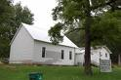

Trimble Campground Church is built on the site of the old campgrounds. The Campground cemetery, where many of our early settlers are buried is located on a high, wooded hill above the church.

The following deed was recorded in 1858. Because of the destruction of our county records by fire, it was re-recorded on August 31, 1909

Know all men by these presents, that we, James Trimble and Phebe G. Trimble, his wife, of the County of Izard and State of Arkansas for and in consideration of the feeling and affection we have to the cause of Christ, especially for the success of the Cumberland Presbyterian Church we have this day given, granted and conveyed and do by these presents give, grant and convey unto Eli Barton, John N. Trimble and Robert D. Scott as Trustees of Union Congregation of the Cumberland Presbyterian Church and to their successors in office as elected by said congregation hence forward forever the following described parcel of land situated in the County of Izard and State of Arkansas and more particularly described as follows to wit. Lot No. 2 of S.W. fl qr of section No. 18 Township No. 18 N of Range No. 10W containing one hundred and seven acres and twenty-eight hundredths more or less to have and to hold the above granted premises to the said Eli Barton, John N Trimble and Robert D. Scott, Trustees in the above named Congregation of the Cumberland Presbyterian Church for the sale, use, benefit, and advantage of the said Church with the exclusive privilege to occupy, control and manage for said church purposes and benefit and the said Trustees and their successors are hereby warranted in the absolute and general control of the same hereby granting that the said premises are free from encumbrances and that we will our heirs and executors and administrators shall defend the title hereby conveyed to the said trustees and their successors in the office forever against all lawful encroachments. In testimony of which we have hereunto set out hands and seals this 1st day of March, A. D. 1858.

Attest E.C. Bone James Trimble (seal)
B. F. Hall Phoebe G. Trimble (seal)

Eli Barton, one of the Trustees named, was the circuit rider who conducted revivals at the Campground. He made the following terse statement in his report to the Presbytery in 1858, ‘Everything satisfactory.’ The church organization was known as the Union Congregation of the Cumberland Presbyterian Church but it was popularly known as Trimble Campground Church. Even after the erection of a church building on the site in 1910 people continued to use the popular name. At a recent meeting of the Presbytery, the name ‘Campground Church’ was made the official name.

W. M. Gentry, in his history, recalled that it was one of the few places where people really camped during Revival Meeting time. ‘There were two sets of log cabins in the early days. One set north of the present church site where part of the Perryman families, the Dave Hudson family and the Bob Campbell family camped. South and a little east of the present church house were the cabins used by the McCoy and the James and John Perryman families.’

‘In appearance, an old-time campground resembled a small village. The meetin’ arbor was a crude affair, built so as to keep out the sun and rain and the sides were always open. All about the arbor were scattered the tents or shacks where the people lived. Every family had its own living quarters. Sometimes these shacks were rather small for the number living therein, but that made no difference, a ‘pallet’ could be made on the floor for the children. The ‘pallets’ were filled with straw, leaves or other bedding material.’

These revival meetings at the Trimble Campgrounds were usually held during ‘laying by time’ the end of cultivating crops and ‘gathering time’, or harvest. Whole families came from miles around by every sort of conveyance from ox cart to horseback.

Some brought cows, chickens, and ‘fattening hogs’. Each year, Capt. Matthews of Pineville donated a beef which was butchered and cooked on the grounds. A spring house was built to chill the meat, eggs, and milk for the huge crowds. One of the factors contributing to the popularity of the campgrounds may have been the many springs. There were at least ten springs on Trimble’s farm. Five of them were all weather springs. The large spring in front of the church was usually damned up and water allowed to rise up in the creek for those who desired baptism by immersion.

‘Uncle Dave Hudson was a Elder in the Campground Church and the Patriarch of the Hudson’s of Izard County today,’ wrote W. M. Gentry in his History of North Izard County. ‘His son, W. R. Hudson, or Bob as he was called, became a Presbyterian preacher noted for his oratory. He could preach a sermon which we thought equal to Dwight L. Moody or DeWitt Talmadge. Bob’s father was a real old fashioned AMEN Elder. Rev. Young Whitfeld’s father, Uncle Allen Whitfield, could match Uncle Dave with his AMENS. When some preacher happened to get going strong in an evangelical way you could hear their AMENS all over the house unless they were drowned out by the shouts of some of our good sisters of that day.’

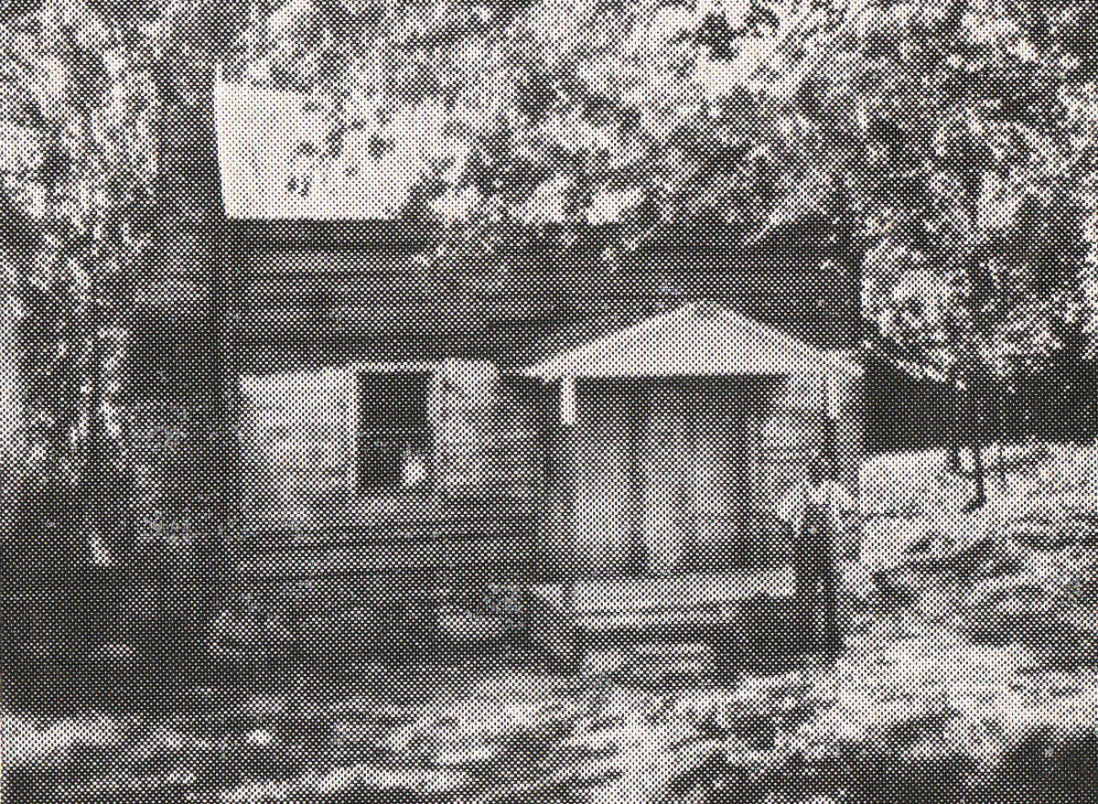
The Trimble House as it appears today [1970]. The present owner, Claude Russell, removed the long front porch, replacing it with a smaller one, reinforced the foundation, and made many minor repairs in an attempt to preserve its northwest Izard County landmark.

For many years, the old house was obscured from view by underbrush but last year the present owner of the farm, Claude Russell, decided to clear out the brush and partially restore the house. This brought about renewed interest in the history of the family and was given further impetus last summer by a visit from a great grand daughter and granddaughter of James Finis Trimble. A great grandson, Hoy B. Trimble, of Yuba City, California, Wrote ‘None of us knew the old Trimble house was still there at Dolph until this last Memorial Day when my sister, Neva, took Aunt Martha (Caldwell) there to try to find the Campground Cemetery and they found the old house still standing. This has been a very rewarding year for we Trimbles. We just had our first family reunion.’

Another granddaughter, Matilda Trimble Holder, (charter member of the society) visited the old home in 1900 or 1901 when a Mr. Welch owned the property. She believes that her grandfather built the house before or soon after his marriage. In any event, it is probably the oldest structure still standing in Izard County. Several people in their late eighties say it was always considered a very old house even then they were children.

The original structure was built of hand hewn logs in the pioneer fashion. It was of square construction 20 by 20 feet with an ‘upstairs’. During the years, changes and additions were made including a lean-to kitchen and weatherboard siding. A metal roof was added some time in the 1900’s. This house was occupied almost continuously until the late 1930’s.

JOHN NEWTON TRIMBLE

John Newton Trimble raised two families at Trimble Flats. His first wife was Mary Cooper of Izard County. They had six children, three sons and three daughters, but only two sons lived to have families. They were Allan Cooper Trimble and James McGregor Trimble.

John Newton’s second wife was a widow, Sarah Elizabeth Hunt Cole of Izard County. They had four children, three daughters and one son. Mary Elizabeth Trimble McNeil (later Burt, and now deceased); Martha Jane Caldwell, now eighty-seven years of age and living in Arlington, Texas; Matilda Josephine Trimble Holder, now eighty-five years of age and also living in Arlington, Texas. John Buchanan Trimble, deceased. All four of the children lived to have families.

The following record of John Newton’s military service was furnished by his daughter, Matilda. ‘John Newton Trimble served in two wars, the Mexican and Civil War. In the Mexican War, he joined the Arkansas Volunteers while he was still in his teens. He was in the Battle of Buena Vista. He also served under General Zachary Taylor and well remembered the General on his favorite war horse, ‘Whitey’. When the gallant Arkansas Colonel Archibald Yell fell in battle, John Trimble helped carry his body onto the boat Vera Cruz for the return trip and off again at New Orleans.’

His service in the Civil War was on the side of the Confederacy as a 1st Lieutenant in Company A Ford’s Battalion, Missouri Cavalry Regiment C.L.A. He served his church as an Elder for sixty years and was an active member of the Masonic Order most of his life. He died at the home of his daughter, Matilda in Harrison, Arkansas on March 23, 1915 at the age of eighty seven, and is buried in Harrison.”

John Newton Trimble’s daughter, Martha Jane Trimble Caldwell, my grandmother, corrected the place of her father’s death. Grandma Caldwell wrote: “This is an error. He died in his own home in Harrison, Ark.”

Note: John Newton Trimble married four times. His wives were
1. Mary Cooper (1834-1879).
2. Sara Elizabeth Hunt Cole Hammond (1841-1891), my great grandmother; killed by lightening.
3. Elizabeth Ann Oakley (1840-1937). She apparently left John Newton Trimble for he married his last wife in 1902 and Elizabeth died in 1937.
4. Harriet Amanda Flinn (1857-1920).

Commercial Appeal, Aug. 26, 1935, by Paul T. Wayland
The Trimble House was built by James and Phebe (Walker) Trimble, in 1847. The house is about 19 feet square, with two rooms and a loft. Trimble House Donation Page is sponsored by the The Izard County Historical & Genealogical Society. It is located at http://eictrimble.blogspot.com/.

